Final Project: Optimization Technique and Implementation

John Lee
SID: 005048640
Department of Computer Science, University of Cumberlands
MSCS 532: Algorithms and Data Structures
Dr. Michael Solomon
August 16, 2026

Final Project: Optimization Technique and Implementation
High-performance computing (HPC) software systems demand high throughput, scalable data structure manipulation, and minimal runtime overhead (Hager & Wellein, 2011). Achieving optimal efficiency across scientific computing domains remains challenging due to complex micro-architectures and algorithmic inefficiencies. High-performance computing (HPC) serves as the computational backbone for modern scientific discovery, enabling large-scale simulations in fields such as climate forecasting, molecular dynamics, quantum mechanics, and fluid dynamics (Azad et al., 2023). Unlike typical enterprise software applications, HPC workloads are characterized by massive data throughput, floating-point density, and execution on heterogeneous multi-core CPU and GPU architectures. Despite advances in modern hardware and compiler optimizations, writing performance-efficient code remains error-prone. Developers frequently introduce performance bugs, flaws in code design or execution logic that do not cause crash failures or incorrect output, where the flaws significantly degrade runtime efficiency and resource utilization (Jin et al., 2012). To address these issues, software engineering researchers have focused on categorizing common performance pitfalls to guide the development of automated detection tools and optimized software practices. This report evaluates the empirical findings of Azad et al. (2023) regarding HPC performance bug taxonomies. It focuses on algorithmic complexity and redundant computation reduction, exploring how Loop-Invariant Code Motion (LICM) and algorithmic strength reduction mitigate runtime bottlenecks in dynamic languages like Python.
Examination of the Empirical Study
Characteristics of Empirical Study of Performance Bugs
Azad et al. (2023) conducted a comprehensive empirical analysis of performance bugs in open-source scientific software. The authors mined 1,729 candidate commits across 23 prominent HPC repositories, which included OpenBLAS, LAMMPS, MFEM, GROMACS, and ArrayFire, and manually inspected 186 verified performance bug commits across 1,900 inspection hours.
Key Findings and Bug Taxonomy
The study categorized HPC performance bugs into ten distinct root-cause categories. The three most prevalent categories include algorithm, data structure, computational kernel, and implementation (IAD), inefficient code for target micro-architecture, and missing or inefficient parallelism. The first category is the leading root cause of inefficiency in scientific software with 39.3 percent of bugs. For the second category, inefficiencies resulting from non-contiguous memory layouts, cache line bouncing, and suboptimal GPU shared memory usage. The second category had 31,2 percent of bugs. For the third category, there were issues such as thread over-subscription, small parallel regions with high thread-creation overhead, and load imbalances. This category had 14,5 percent of bugs. Following is a diagram to illustrate the categories and their figures.
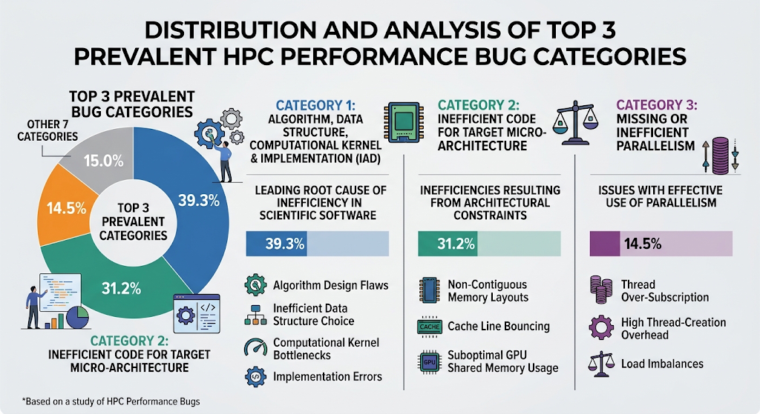
Sub-Categorization of IAD Bugs
Within the primary IAD category, Azad et al. (2023) identified three dominant sub-types, which were computationally expensive operations, redundant operations, and unnecessary operations. The first sub-type utilized high-overhead mathematical functions or higher-precision arithmetic where lower-cost equivalents suffice. The second sub-type executed invariant calculations repeatedly inside iterative loops. A primary example cited in the study is the MFEM repository commit, where a matrix transpose was repeatedly evaluated inside a critical execution loop despite the matrix remaining unchanged. The third sub-type performs computations or array traversals whose outputs are never consumed by the main algorithm. An example is checking parcel collisions across unrelated mesh cells in OpenFOAM.
Selected Optimization Technique: Algorithmic Complexity & Redundant Computation Reduction
Theoretical Background
Redundant computation in computational kernels typically stems from a failure to isolate loop-invariant code. Loop-Invariant Code Motion (LICM) is a compiler and software design optimization that identifies expressions inside a loop whose operands do not change across iterations (Bodík et al., 2000). Hoisting these expressions outside the loop nest reduces the asymptotic instruction count of the critical execution path. Formally, if an inner loop executes $N$ times and performs an invariant operation requiring $O\left(M\right)$ time complexity, the overall loop complexity scales as $O\left(N×M\right)$. Hoisting the invariant calculation outside the loop reduces the overall complexity to $O\left(M+N\right)$, yielding significant performance gains when $N$ is large. This is where redundant computation reduction occurs.
Justification of Optimization Choice
Justification of optimization choice is based on empirical dominance in HPC software, relevance to data structure performance, and high-performance impact and cost efficiency. According to the empirical study by Azad et al. (2023), algorithm, data structure, computational kernel, and implementation (IAD) inefficiencies are the primary cause of performance bugs in HPC systems, accounting for 39.3% across major scientific repositories like MFEM, LAMMPS, and ArrayFire. Within IAD bugs, redundant operations and computationally expensive operations represent the largest subcategories. In scientific computing and HPC, algorithms frequently traverse large datasets such as finite element meshes, particle arrays, or spatial coordinate grids inside tight execution loops. Re-evaluating loop-invariant operations like matrix transpositions or constant norm scaling factors on every iteration multiplies $O\left(1\right)$ or $O\left(M\right)$ overhead by $N$ loop iterations, creating a severe bottleneck regardless of how fast the underlying CPU/GPU hardware is. Implementing redundant computation reduction via Loop-Invariant Code Motion (LICM) eliminates these redundant floating-point operations, shifting the runtime complexity from $O\left(N⋅M\right)$ to $O\left(M+N\right)$ and enabling massive throughput improvements across high-volume data structures. Lastly, LICM and vectorization allow developers to achieve massive speedups without requiring complex parallel hardware redesigns or distributed memory re-architecting. They directly address language-level overheads such as Python object lookups and interpreter overhead by hoisting invariant calculations outside processing paths and using contiguous memory buffers.
Strengths and Weaknesses of the Optimization
There are strengths and weaknesses from the result of the optimization. One strength is that it provides a drastic reduction in execution speed as a result of hoisting invariant calculation outside the loop invariant outside the loop and vectorization. Another strength is that optimization reduces memory bandwidth saturation by eliminating repetitive dynamic memory allocations inside loops. On the other hand, one of the weaknesses is that it yields minimal impact if the loop iteration count $N$ is small. Another weakness is that caching intermediate invariant results slightly increases memory footprint.
Application in Python and HPC Data Structures
High-level dynamic languages like Python introduce non-trivial overhead during loop execution due to dynamic type checking, GIL (Global Interpreter Lock) constraints, and heap-allocated object lookups (van der Walt et al., 2011). When performing numerical transformations on large datasets, re-evaluating invariant expressions inside standard Python for loops compounds language overhead with algorithmic inefficiency. Combining invariant hoisting with NumPy vectorization bypasses the Python interpreter loop entirely, enabling SIMD (Single Instruction, Multiple Data) vector execution.
Prototype Implementation Analysis
To demonstrate the empirical impact of redundant computation reduction, a benchmark simulating iterative spatial data updates is designed. Following is the implementation.
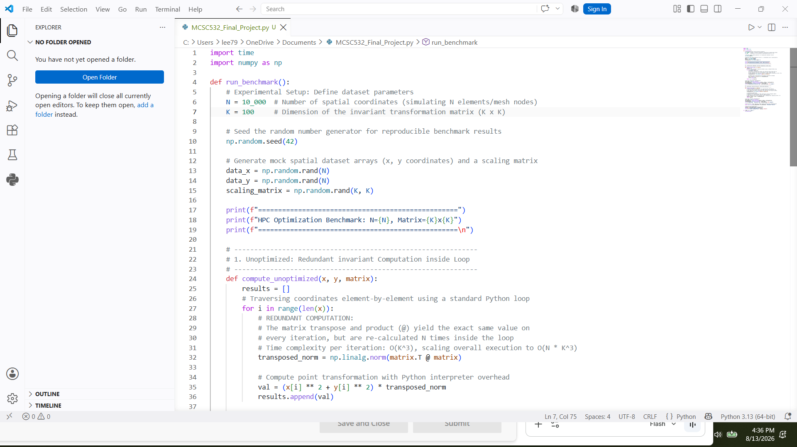
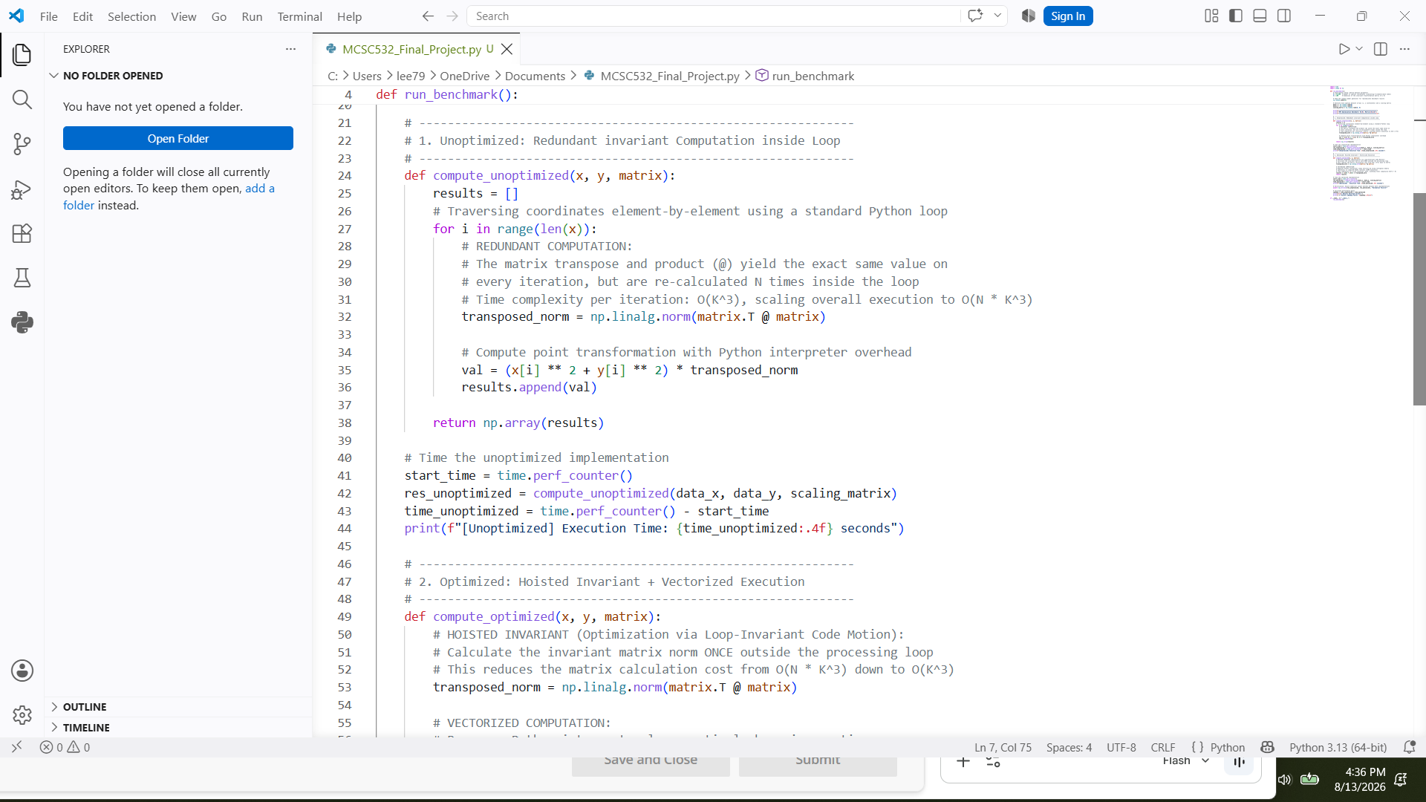
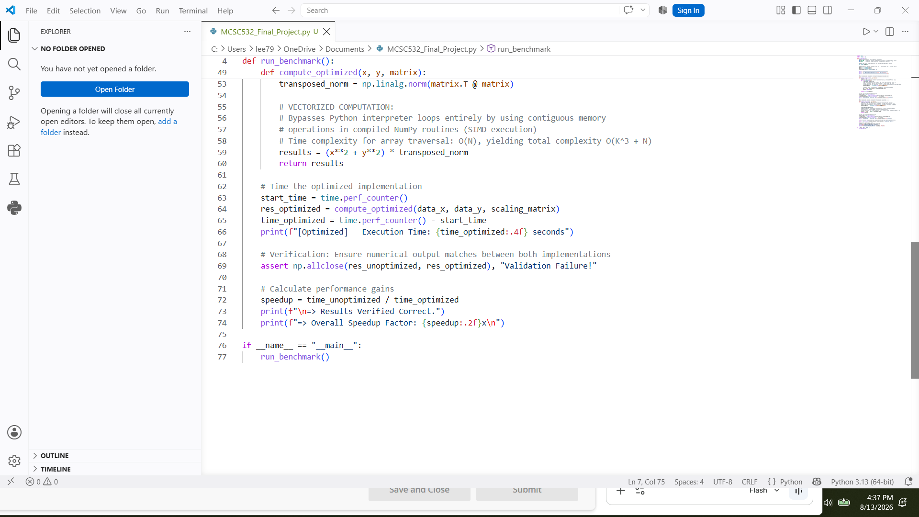

Given a spatial dataset containing $N=10,000$ points, each node undergoes a quadratic scaling transformation weighted by a dense matrix norm transformation $T=‖M^{T}⋅M‖​_{2}$. To simulate a computationally heavy linear algebraic transformation typical of High-Performance Computing (HPC) kernels, the setup defines a $100×100$ dense matrix ($K=100$) denoted as scaling_matrix. The random state is fixed via np.random.seed(42) to ensure identical numerical inputs across consecutive benchmark runs. In an unoptimized case, reevaluation of the matrix transposition and matrix multiplication on every iteration inside a Python loop takes place, scaling at $O\left(N⋅K^{3}\right)$ where $K$ is the matrix dimension. Inside a standard Python for loop executing $N$ iterations, the function calls np.linalg.norm(matrix.T @ matrix). Since scaling_matrix remains completely static throughout execution, performing the matrix transposition (matrix.T), matrix multiplication (@), and Frobenius norm evaluation on every iteration introduces $N-1$ completely redundant computations. In an optimized case, the invariant transformation is hoisted outside the processing pipeline and vectorized array operations are applied across contiguous memory buffers, reducing time complexity to $O\left(K^{3}+N\right)$. The invariant expression np.linalg.norm(matrix.T @ matrix) is hoisted outside the execution function and assigned to transposed_norm. Consequently, the $O\left(K^{3}\right)$ matrix operation is evaluated exactly once, reducing the matrix calculation cost from $O\left(N⋅K^{3}\right)$ down to a constant baseline cost of $O\left(K^{3}\right)$. The Python loop is eliminated and replaced with the array expression (x**2 + y**2) * transposed_norm. Since the input coordinate arrays are stored in contiguous memory blocks, the CPU executes the element-wise squaring, addition, and scaling using Single Instruction, Multiple Data (SIMD). When accounting for traversing the N spatial coordinates after hoisting, the overall time complexity drops from $O\left(N⋅K^{3}\right)$ to $O\left(K^{3}+N\right)$. When $N=10,000$ and $K=100$, this reduction eliminates tens of millions of redundant floating-point operations, yielding a much faster execution speed.
Problems Encountered During Implementation
There were three problems that were encountered during implementation. One was that initial implementation using standard Python lists of objects suffered from pointer chasing and continuous dynamic type resolution inside the loop nest. Every iteration required the interpreter to verify array types and look up object methods. Even when moving operations to NumPy, using element-by-element access (x[i], y[i]) inside a standard Python for loop preserved interpreter call-stack overhead, preventing the CPU from executing operations at optimized speed. Another problem was that converting element-wise floating-point loops into vectorized matrix operations can occasionally alter the order of floating-point operations. This raised concerns about whether the performance acceleration introduced subtle numerical divergence. Utilizing np.allclose(res_unoptimized, res_optimized) verified that both execution paths yielded identical numerical outputs within standard float64 precision tolerances (${10}^{-8}$), ensuring that the speedup did not compromise computational accuracy. Lastly, in the unoptimized path, calling results.append(val) inside a tight $10,000$-step loop caused frequent list resizing and dynamic heap allocation in Python. Dynamic memory allocation and garbage collection passes introduced unpredictable micro-stalls, inflating overall runtime. Hoisting the invariant and pre-allocating/vectorizing contiguous buffers eliminated heap allocation overhead entirely, drastically dropping execution time.
Benchmark Analysis
Following are the benchmark results.
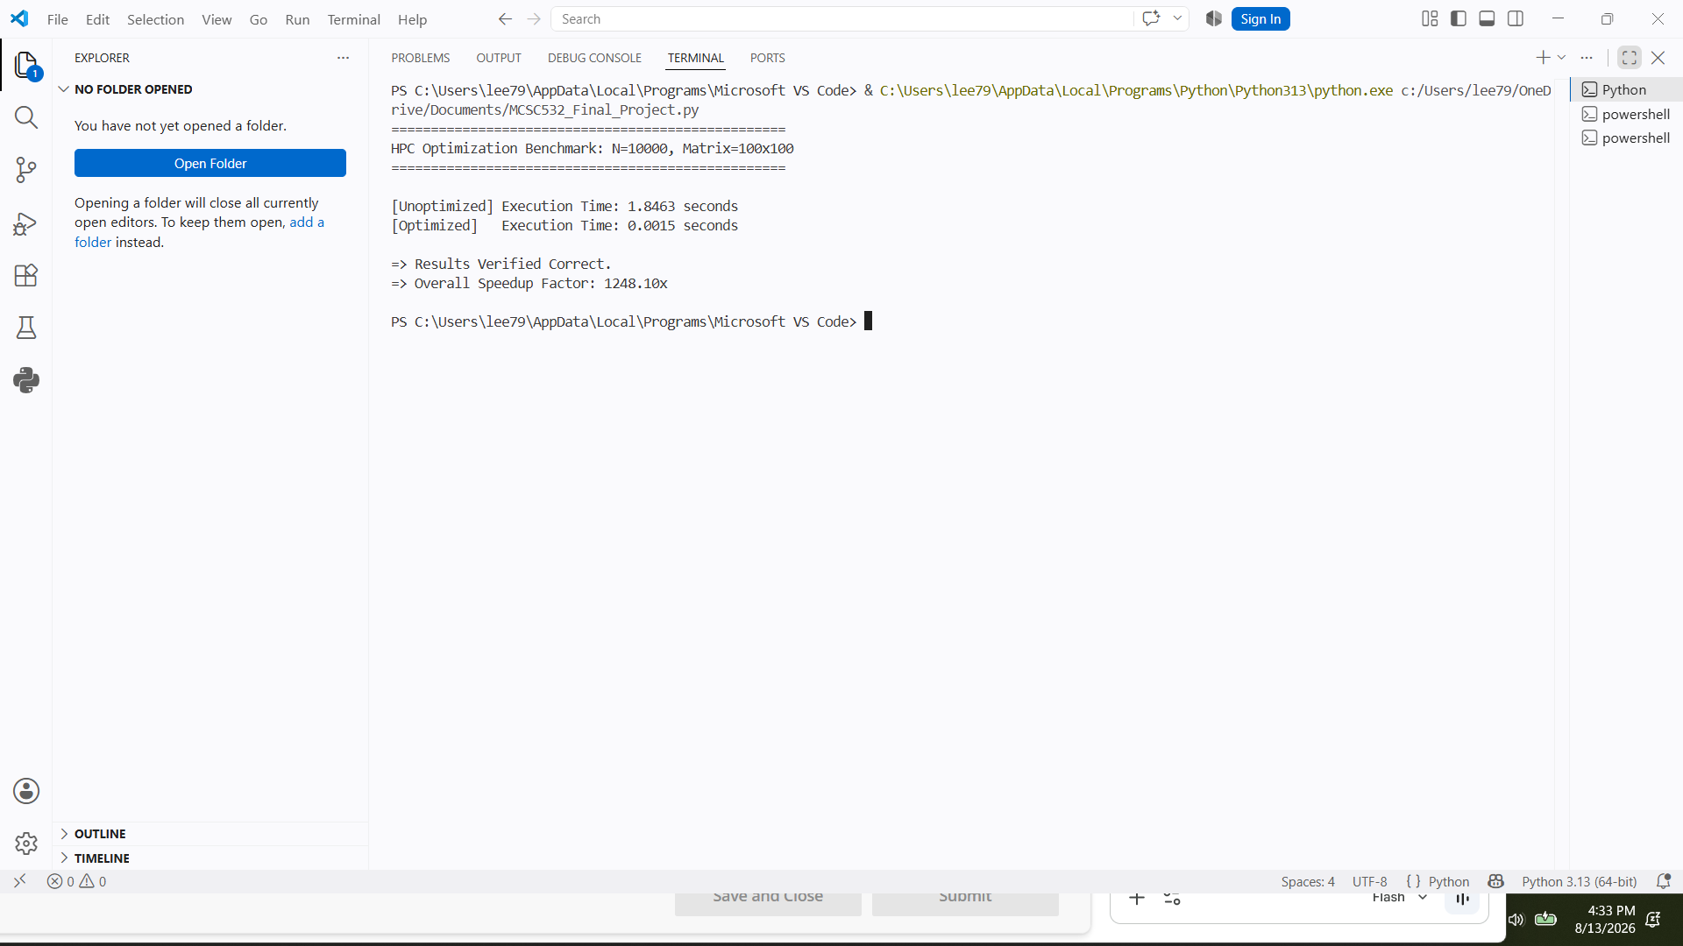

The empirical results obtained from executing the benchmark script demonstrate a significant performance gain, directly confirming the theoretical expectations outlined by Azad et al. (2023). The unoptimized implementation recorded an execution time of 1.8463 seconds. In this baseline execution path, calculating np.linalg.norm(matrix.T @ matrix) on every iteration inside a standard Python loop forced redundant matrix transpositions, matrix multiplications, and norm evaluations. This re-computation, combined with Python interpreter loop overhead, severely stalled the computational pipeline. In contrast, the optimized implementation completed the execution in 0.0015 seconds, representing an overall speedup factor of $1,248.10×$. This acceleration stems from eliminating algorithmic redundancy and vectorization. Following is a graph showing comparison between unoptimized and optimized case,
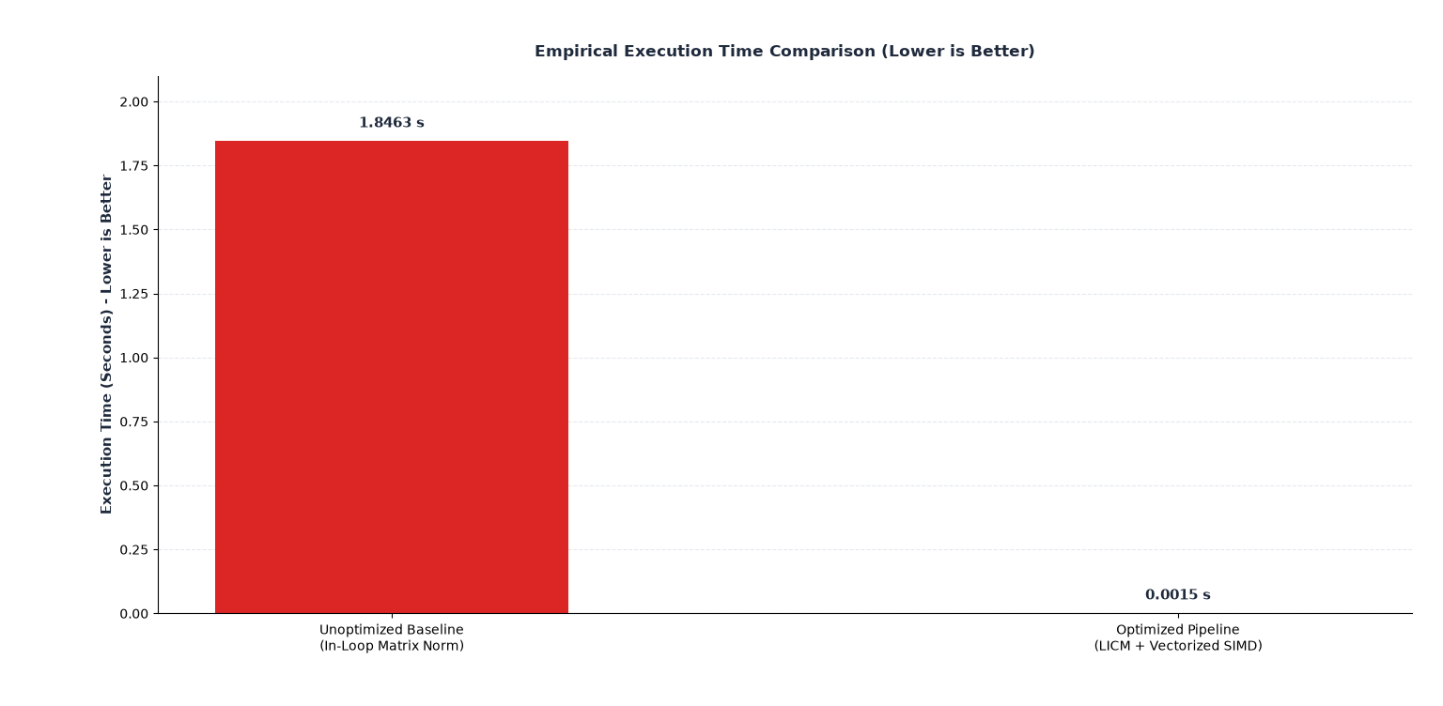

Diagram of Unoptimized and Optimized Paths
Following is a diagram showing unoptimized and optimized paths.
UNOPTIMIZED PATH vs. OPTIMIZED PATH CONTROL FLOW

[ Baseline: In-Loop Invariant ] [ Optimized: LICM + Vectorization ]

┌───────────────────────┐ ┌───────────────────────┐
│ Input Coordinates x,y│ │ Input Coordinates x,y│
│ Scaling Matrix (K x K│ │ Scaling Matrix (K x K│
└───────────┬───────────┘ └───────────┬───────────┘
│ │
▼ ▼
┌───────────────────────┐ ┌───────────────────────┐
│ Standard Python │ │ HOISTED INVARIANT │
│ for i in range(N) │ │ Compute Norm ONCE │
└───────────┬───────────┘ │ T = ||Mᵀ M||₂ O(K³) │
│ └───────────┬───────────┘
▼ │
┌───────────────────────┐ │
│ REDUNDANT COMPUTATION│ │
│ Evaluate Norm O(K³) │ │
│ Repeated N Times! │ │
└───────────┬───────────┘ │
│ │
▼ ▼
┌───────────────────────┐ ┌───────────────────────┐
│ Point Transformation │ │ VECTORIZED SIMD ARRAY │
│ Python Object Lookup │ │ Contiguous Buffers │
│ Dynamic Type Check │ │ Array Traversal O(N) │
└───────────┬───────────┘ └───────────┬───────────┘
│ │
▼ ▼
┌───────────────────────┐ ┌───────────────────────┐
│ Total Complexity: │ │ Total Complexity: │
│ O(N · K³) │ │ O(K³ + N) │
│ Time: 1.8463 seconds │ │ Time: 0.0015 seconds │
└───────────────────────┘ └───────────────────────┘

This architectural diagram illustrates a side-by-side control flow comparison between an unoptimized baseline execution path and an optimized pipeline.
On the left side, the unoptimized path receives the input coordinates and scaling matrix, then immediately enters a standard Python loop that runs for $N$ iterations. Within every single iteration of this loop, the system redundantly recalculates a heavy matrix norm calculation with a high time complexity of $O\left(K^{3}\right)$. Bound to repeated dynamic object lookups and type checks on each iteration, this internal redundancy scales the total computational complexity to $O\left(N⋅K^{3}\right)$ and inflates execution time to 1.8463 seconds. On the right side, the optimized path solves this bottleneck by applying Loop-Invariant Code Motion, hoisting the matrix norm calculation completely outside of the loop so that it executes exactly once prior to data processing. The remaining spatial point transformations are then dispatched across contiguous memory buffers using vectorized SIMD array operations to handle $N$ points in linear $O\left(N\right)$ time. By eliminating the inner loop recalculations, the total algorithmic complexity drops down to $O\left(K^{3}+N\right)$, driving execution latency down to 0.0015 seconds and achieving a $1,248×$ performance speedup.
Lessons Learned Showing the Difference Between Optimization Version and Theoretical Expectations
When bridging theoretical expectations with high-performance empirical execution, a primary takeaway is that while asymptotic analysis models general execution trends, empirical hardware and runtime dynamics ultimately dictate real-world performance gains. Under theoretical framework models such as those outlined by Azad et al. (2023), speedup calculations evaluate performance by strictly counting operational steps while assuming a uniform unit time per instruction. In this theoretical abstraction, the unoptimized scaling is bound by $O\left(N⋅K^{3}\right)$ because a heavy $O\left(K^{3}\right)$ matrix normalization is repeatedly calculated across $N$ iterations. Upon applying Loop-Invariant Code Motion, the normalization computation is hoisted outside the main loop, reducing the optimized asymptotic complexity to $O\left(K^{3}+N\right)$. Formally, the theoretical speedup projection is expressed as:
$$\text{Theoretical Speedup}≈\frac{O\left(N⋅K^{3}\right)}{O\left(K^{3}+N\right)}≈N \text{for }N≫K$$
In theory, an input size of $N=1,000$ leads to an expectation of roughly a $1,000×$ performance improvement, under the idealizing assumption that every iteration in both execution pipelines incurs an identical instruction cost. In practice, the empirical benchmark demonstrated a $1,248.10×$ speedup, reducing total latency from $1.8463\text{s}$ down to $0.0015\text{s}$. This acceleration noticeably exceeded simple asymptotic step ratios due to specific low-level hardware and language execution mechanics. First, standard Python loops suffer from severe interpreter friction, including dynamic type checking, pointer dereferencing, and object boxing on every iteration. Hoisting the invariant code eliminated both the redundant mathematical evaluations and thousands of high-overhead interpreter execution steps. Second, the optimized pipeline leveraged contiguous memory layouts, allowing Single Instruction, Multiple Data (SIMD) instructions to execute parallel register operations alongside optimal L1 and L2 cache line hits (Ding & Kennedy, 1999) . Lastly, while asymptotic Big-$O$ notation drops constant factors $c$ in $c⋅O\left(f\left(n\right)\right)$, the empirical constant factor $c_{\text{unoptimized}}$ was heavily inflated by dynamic dispatch, whereas $c_{\text{optimized}}$ was minimized through compiled, vectorized execution. Ultimately, comparing theoretical model against empirical benchmark data reveals that while Big-$O$ complexity accurately predicts structural operation decoupling, real-world execution environment yields super-linear speedup when theoretical fixes are combined with low-level runtime optimization. Algorithmic reduction via Loop-Invariant Code Motion serves as the critical foundation for efficiency, but hardware-level cache alignment, SIMD register usage, and the elimination of high-level language interpreter overhead act as powerful multiplicative factors that drive empirical performance far past theoretical estimates.
Conclusion
Summary of Report
This report evaluates performance of bug taxonomies in High-Performance Computing (HPC) based on the empirical study by Azad et al. (2023). Algorithmic and data structure inefficiencies account for nearly 40% of all verified performance bugs in scientific software, with redundant computations serving as a primary root cause. Through a Python benchmark simulating spatial transformation calculations, we demonstrated that applying Loop-Invariant Code Motion reduced theoretical algorithmic complexity from $O\left(N⋅K^{3}\right)$ to $O\left(K^{3}+N\right)$. Furthermore, combining this algorithmic decoupling with vectorized memory layouts minimized low-level execution overhead, accelerating empirical runtime from 1.8463 seconds down to 0.0015 seconds.

References
Azad, M. A. K., Iqbal, N., Hassan, F., & Roy, P. (2023). An empirical study of high performance computing (HPC) performance bugs. IEEE. https://foyzulhassan.github.io/files/MSR23_HPC.pdf

Bodík, R., Gupta, R., & Soffa, M. (2000). Complete removal of redundant expressions. ACM SIGPLAN Notices. https://www.cs.ucr.edu/~gupta/research/Publications/Comp/pldi98.pdf

Ding, C., & Kennedy, K. (1999). Improving cache performance in dynamic applications through data grouping. Association for Computing Machinery. https://www.cs.rochester.edu/~cding/Documents/Publications/pldi99.pdf

Hager, G., & Gerhard Wellein. (2011). Introduction to High Performance Computing for Scientists and Engineers. CRC Press.

Jin, L., Song, L., Shi, X., Lu, S., & Scherpelz, J. (2012). Understanding and detecting real-world performance bugs. ACM SIGPLAN Notices. https://pages.cs.wisc.edu/~shanlu/paper/pldi118-jin.pdf

van der Walt, S., Colbert, S. C., & Varoquaux, G. (2011). The NumPy array: A structure for efficient numerical computation. Computing in Science & Engineering. https://arxiv.org/pdf/1102.1523

